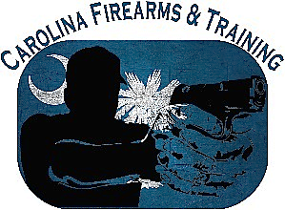
Carolina Firearms & Training
1002 Gordon Street,
Georgetown, SC 29440

Instructor Notes
Class: ___________ Date: ___________

Event | Time
Class begins | AM/PM
Begin lesson 1 | AM/PM
Begin lesson 2 (legal aspects) | AM/PM
Begin legal aspects test | AM/PM
Begin lesson 3 | AM/PM
Begin firearm safety test | AM/PM
Begin firearm dry fire, live fire exercises, and firearm qualification | AM/PM
 | AM/PM
 | AM/PM
 | AM/PM
 | AM/PM
 | AM/PM
 | AM/PM
 | AM/PM

